Optimizing Agriculture Using Machine Learning Techniques

Abstract
This project focuses on developing an integrated system for agricultural optimization, including soil prediction, crop recommendation, plant disease detection, fertilizer suggestion, and crop yield prediction. The goal is to assist farmers in making informed decisions to improve agricultural productivity and sustainability through data-driven insights. The system leverages advanced machine learning and deep learning techniques to provide comprehensive support across various aspects of farming. The system begins by analyzing soil images to classify the soil type using a Convolutional Neural Network (CNN) model. Based on the identified soil type, it recommends suitable crops using Random Forest and XGBoost algorithms. The system also includes a plant disease detection module using a CNN model based on the MobileNet architecture. Farmers can upload leaf images, and the model identifies common diseases like blight, rust, and leaf spot. Early detection allows timely intervention, reducing crop loss and improving produce quality. For each disease, the system provides management strategies to prevent further spread. Fertilizer recommendations are made using Random Forest and XGBoost based on plant disease. Finally, the project employs LSTM to predict crop yield by considering various location, name of the area and soil parameters. This integrated approach assists farmers in making informed decisions for optimal crop selection, disease management, and maximizing agricultural productivity. Overall, the project demonstrates the potential of AI-driven solutions to address complex challenges in agriculture and contribute to global food security efforts. The project highlights AI's potential in tackling agricultural challenges, supporting sustainable farming practices, optimizing resources, and boosting productivity, for global food security.
Keywords – Soil analysis, Crop yield prediction, plant disease identification, CNN, Random Forest, XGBoost, and LSTM.

CHAPTER 1
INTRODUCTION

1.1 Aim of Study
The aim of this study is to develop an integrated system that leverages machine learning and deep learning techniques to optimize agricultural processes, including soil prediction, crop recommendation, plant disease detection, fertilizer suggestion, and crop yield prediction. The system is designed to assist farmers in making data-driven decisions that improve agricultural productivity, enhance sustainability, and reduce resource wastage.

1.2 Objectives
The Next-Gen Groundwater Models project aims to predict groundwater availability using advanced machine learning techniques. K-means clustering is first applied to the aqua dataset to categorize regions into clusters based on groundwater levels, identifying areas with varying water availability. Two classification models, Random Forest and Deep Convolutional Neural Networks (DCNN), are then utilized to predict water-bearing zones. Random Forest uses an ensemble approach for robust predictions, while DCNN captures intricate patterns in the data to enhance accuracy. The model’s performance is evaluated using metrics like RMSE and MAE, and visualizations such as graphs and charts are generated to illustrate groundwater usage for both domestic and industrial purposes. The system is designed to support informed decision-making by testing and analyzing new data for real-time groundwater prediction.

1.3 Motivation
The motivation behind this study stems from the need to address the growing challenges in agriculture, such as increasing global demand for food, limited natural resources, and the impact of climate change. Farmers face the dual challenge of maximizing productivity while ensuring sustainability. Traditional farming methods are often inefficient, resulting in resource wastage, crop diseases, and unpredictable yields. By harnessing the power of AI and machine learning, this study seeks to provide innovative solutions to these challenges, helping farmers make better decisions, reduce crop losses, and increase overall productivity. The project also aims to contribute to global food security efforts by promoting sustainable farming practices.

1.4 Scope of Study
The scope of the Next-Gen Groundwater Models project involves developing a predictive system for groundwater availability by leveraging machine learning techniques. It includes clustering regions using K-means based on groundwater levels, and utilizing Random Forest and Deep CNN models to classify and predict water-bearing zones. The project also encompasses generating visualizations like charts and graphs to represent groundwater usage trends, supporting decision-making for domestic and industrial applications. Additionally, the model's accuracy will be evaluated using RMSE and MAE, ensuring reliable predictions for future groundwater management.
1.5 Introduction
The study focuses on integrating these machine learning and deep learning techniques into a unified system that can be used by farmers to optimize their farming practices. Additionally, the research emphasizes sustainability, ensuring that the system helps reduce resource wastage and minimize environmental damage.
Agriculture is a critical sector that sustains global food security, yet it faces numerous challenges including unpredictable climate conditions, soil degradation, plant diseases, and suboptimal resource management. To address these issues, advancements in artificial intelligence (AI) and machine learning (ML) offer innovative solutions for optimizing agricultural practices. This project introduces an integrated system aimed at revolutionizing traditional farming by providing data-driven insights for soil analysis, crop recommendation, plant disease detection, fertilizer suggestion, and crop yield prediction. By leveraging cutting-edge AI techniques, the system enables farmers to make informed decisions that enhance productivity and sustainability.
The core of the system begins with soil analysis, where a Convolutional Neural Network (CNN) model is utilized to classify soil types based on image inputs. Understanding the soil type allows for precise crop recommendations, further optimized using Random Forest and XGBoost algorithms. This data-driven approach ensures that crops are selected based on the most compatible soil conditions, boosting the likelihood of higher yields. Additionally, a plant disease detection module, also powered by a CNN model based on the MobileNet architecture, enables early identification of common diseases through image uploads of affected leaves. The system provides not only diagnoses but also actionable management strategies, allowing farmers to mitigate disease spread and reduce crop losses.
Beyond disease detection, the system offers tailored fertilizer recommendations that consider plant diseases, ensuring nutrient requirements are met efficiently. Crop yield prediction is another critical feature, implemented through Long Short-Term Memory (LSTM) networks that analyze location and soil parameters to forecast production levels. By integrating these various machine learning models, the system offers a comprehensive solution that addresses multiple facets of modern agriculture, contributing to more informed farming practices and improving overall food security.
This paper addresses the limitations of previous reviews on plant disease detection by offering a comprehensive overview of recent studies in the field. It focuses on plant leaf disease recognition using deep learning techniques, hyper-spectral imaging, and image processing. The review aims to assist researchers by providing valuable insights into the use of deep learning methods for plant disease detection. [1]
Early detection of plant leaf infections is crucial in agriculture, with various traditional methods like thermography and DNA/RNA-based biosensors previously used. However, these techniques faced challenges like inconsistency and inefficiency. To address these issues, researchers have turned to image processing with deep learning (DL) and machine learning (ML) algorithms. This paper is the first to summarize various findings on detecting and classifying plant diseases using ML and DL, highlighting recent advancements in DL models and identifying research gaps in the field. [2]
The proposed work aims to develop a model that classifies different soil series and recommends suitable crops for specific areas in six Upazillas of the Khulna district, Bangladesh. Using machine learning methods, the model identifies soil series based on various chemical features and suggests appropriate crops by considering geographical attributes. This approach provides localized crop recommendations, helping improve agricultural productivity in the region. [3]
This research paper explores the use of deep learning and machine learning techniques for classifying soil types and estimating soil pH levels. By analyzing image features as independent variables, the study investigates state-of-the-art methodologies for soil characterization. It also presents a case study demonstrating the effectiveness of these techniques in accurately classifying soil types and predicting pH levels.[4]
The primary goal of crop yield estimation is to enhance agricultural production, and established models are utilized to achieve this. Machine learning (ML) has gained global traction for its efficiency in forecasting and pattern recognition, significantly improving crop yield rates even in adverse conditions. By applying ML algorithms for crop selection, losses in yield can be minimized despite environmental challenges. [5]
Optimizing agriculture through machine learning techniques involves utilizing data-driven approaches to enhance various farming practices. Machine learning algorithms can predict crop yields by analyzing historical data, weather patterns, and soil conditions, enabling farmers to make informed planting decisions. Additionally, these techniques assist in soil analysis by classifying soil types and predicting properties like pH and nutrient content, which helps in selecting suitable crops. Moreover, machine learning aids in pest and disease detection through image analysis, allowing for early interventions to minimize crop loss. By optimizing irrigation management and resource utilization, machine learning fosters precision farming, ultimately leading to increased agricultural productivity and sustainability.

Machine learning algorithms are fundamental to artificial intelligence and data science, enabling computers to learn and improve from data without explicit programming. They have a wide range of applications, including image and speech recognition, recommendation systems, and data analysis. In supervised learning, algorithms are trained on labeled data to make predictions or classifications. For classification tasks, common algorithms include Logistic Regression, Decision Trees, Random Forest, Support Vector Machines (SVM), and Neural Networks. Regression algorithms, such as LinearRegression and Polynomial Regression, predict continuous outcomes like prices or scores.Unsupervised learning involves finding patterns or structures in unlabeled data.

Clustering algorithms like K-Means, Hierarchical Clustering, and DBSCAN group similar data points, aiding market segmentation and anomaly detection. Dimensionality reduction algorithms like Principal Component Analysis (PCA) and t-Distributed Stochastic Neighbor Embedding (t-SNE) help in reducing the number of features in a dataset while preserving key information.This approach combines labeled and unlabeled data, useful when acquiring fully labeled data is costly or time-consuming. It's used in various applications, including text classification and image recognition.In reinforcement learning, agents learn to make sequences of decisions by receiving feedback in the form of rewards. It's crucial in robotics, game playing, and autonomous systems.These machine learning algorithms play a pivotal role in solving complex problems and making data-driven decisions across diverse domains.[1]
In recent years, agriculture has witnessed a significant transformation due to the rapid advancements in technology, particularly in the field of artificial intelligence (AI) and machine learning (ML). These technologies have the potential to optimize agricultural practices by offering intelligent solutions for complex challenges that farmers face today. As global demand for food increases, agricultural productivity and sustainability become paramount. Farmers must not only produce more with limited resources but also manage their crops effectively to ensure high-quality yields. This is where machine learning techniques come into play, providing data-driven insights to make informed decisions, thereby revolutionizing the way agricultural processes are carried out.
This project focuses on developing an integrated system that employs advanced machine learning and deep learning techniques to optimize various aspects of farming. The system is designed to assist farmers in making informed decisions related to soil prediction, crop recommendation, plant disease detection, fertilizer suggestion, and crop yield prediction. By analyzing real-time data and using predictive models, the system enhances the overall productivity of farms while promoting sustainable farming practices. Each of these functionalities serves as a critical component of agricultural management, aiming to address specific challenges faced by farmers.
The process begins with soil prediction, where the system uses a Convolutional Neural Network (CNN) model to analyze soil images and classify them into distinct soil types. Soil classification is essential as different crops require different soil conditions for optimal growth. Based on the identified soil type, the system recommends suitable crops using machine learning algorithms such as Random Forest and XGBoost. These algorithms leverage vast datasets of soil and crop information to provide precise recommendations that enhance crop productivity and minimize resource wastage.
In addition to soil and crop management, the system incorporates a plant disease detection module built on the MobileNet architecture, which allows farmers to identify diseases early on. This module uses CNN technology to analyze leaf images uploaded by farmers and detect common diseases such as blight, rust, and leaf spot. Early detection is critical for timely intervention, reducing crop loss, and improving overall produce quality. By providing management strategies for each detected disease, the system empowers farmers to take preventive measures, thereby mitigating the impact of plant diseases on crop yields.
Furthermore, the system provides fertilizer recommendations based on the identified soil type and plant health status. Using Random Forest and XGBoost algorithms, the system suggests appropriate fertilizers in the right quantities to ensure balanced nutrition for the crops. This not only promotes healthy plant growth but also helps in reducing the overuse of chemical fertilizers, which can harm the environment and deplete soil quality over time.
Crop yield prediction is another vital aspect of the system, where Long Short-Term Memory (LSTM) models are employed to predict future crop yields. These predictions are based on various factors such as soil parameters, location, and environmental conditions, allowing farmers to plan better and allocate resources efficiently. By providing accurate yield forecasts, the system helps farmers anticipate potential outcomes and take necessary actions to optimize productivity.
The project demonstrates the significant role that AI-driven solutions can play in addressing the multifaceted challenges of agriculture. From optimizing resource usage to predicting future crop yields, machine learning techniques can offer farmers a comprehensive suite of tools to improve both the quality and quantity of their produce. This not only benefits the farmers by increasing profitability but also contributes to global food security efforts by ensuring a stable and sustainable food supply.
In conclusion, the integration of machine learning in agriculture offers immense potential to enhance farming practices and address critical challenges such as resource optimization, disease management, and yield prediction. By providing farmers with intelligent, data-driven insights, this project highlights the transformative power of AI in promoting sustainable agriculture and ensuring food security in the face of growing global demand.
Agriculture is a vital element that has a significant role in nourishing the world’s growing population. To keep pace with the increasing demand for foodstuffs, farmers need to make the best use of them to reap output while minimizing losses. Forecasting and examining reap growth is a serious part of modern agriculture, and machine learning has become a powerful tool to achieve this goal line [1,2]. Smart farming, or precision agriculture, is a modern farming conduct that utilizes recent technology to optimize reap production and minimize waste. Smart farming aims to increase reap output while minimizing using resources such as water, fertilizer, and energy [3].
Figure 1 illustrates IoT and machine learning-based crop analysis and prediction processes. Over the years, numerous elements and technologies have been integrated into the architecture of a smart farm, such as sensing and monitoring systems, Internet of Things (IoT) sensors, data analytics and Artificial Intelligence (AI), precision agriculture techniques, remote monitoring and control, automated systems, livestock management systems, cloud computing and big data storage, energy management, and farm management software, to enhance farming practices and boost productivity [4,5,6]. In smart farming, the Internet of Things is considered one of the key contributing technologies used. IoT sensors can be utilized to monitor soil moisture, temperature, and other environmental aspects [7], and the gathered data from the IoT sensors can be used to define the best time to plant, water, and harvest reaps. By using IoT sensors, farmers can guarantee that the reaps receive the right amount of water and nutrients, which can improve their quality and yield [8,9].
In recent years, machine learning applications have entered our lives in many areas, from health to defense industries and education to urbanization, and have taken an effective way in decision-making situations. At the same time, it started to produce information and technology solutions by forming the basis of the newly emerging search engine infrastructure, such as ChatGPT (Chat Generative Pretrained Transformer from the OpenAI [10], Google Bard [11], and similar AI-based chatbots and some other tools). Many research companies reveal that new trends will grow even more in various platforms. In this respect, the effect of machine learning-oriented systems and solutions in the technology field will increase its effectiveness as a huge multiplier, and many sectors, such as chip design [12] and traffic estimations [13], would be changed by enforcing machine learning models.
Generally, it is essential to collect and analyze accurate data using machine learning algorithms. The data collection is critical in both quality and size to obtain accurate results and make high predictions. In general, big data have size, speed, and various characteristics. Their large size helps eliminate randomness and allows the data to provide detailed results. In addition, large-scale analysis data could be more structured. Using more than one dataset from different sources in the analysis will provide a higher success rate. Many sources, such as sensors, social media, digital networks, physical devices, the stock market, and health centers, are sufficient data sources. This data can be accessed through APIs, web collection, and direct access paths. Data can be in two forms: static datasets or stream data. Data from different platforms are incorporated into the data processing operations. Analysis using these collected data makes data cleaning and preprocessing more critical while using machine learning algorithms.
Machine learning algorithms can analyze vast amounts of data from IoT sensors and other sources. It is a rapidly growing field that has the potential to transform the way we predict and analyze crop growth and output. Machine learning algorithms use statistical/mathematical models and algorithms to analyze data and make predictions, enabling computer systems to learn and improve from experience without being explicitly programmed [14]. In agriculture, especially in the cultivation area, machine learning algorithms can be trained on comprehensive data collected from farms, such as weather patterns, soil properties, crop growth stages, and pest and disease outbreaks. By evaluating the collected data, machine learning models can forecast reap growth, output, and quality with high accuracy [15].
A noteworthy application of machine learning in agriculture is precision farming, which includes employing data and technology to optimize agricultural conducts such as fertilization, irrigation, and pest control to improve reap output and quality. Machine learning models can examine bulky amounts of data from several sources, such as satellite imagery, drone footage, and soil sensors, to craft comprehensive maps of reap growth, nutrient levels, and moisture content. Farmers can utilize these maps to regulate their farming conducts, such as applying fertilizer or watering specific field areas, to maximize reap output and minimize waste [16]. Machine learning can also help farmers identify the most profitable crops to plant based on market demand and environmental factors. By analyzing historical market data and weather patterns, machine learning models can predict the demand for different crops and suggest optimal planting times and locations [17]. This can help farmers maximize their profits while minimizing the risk of crop failure. In addition to predicting crop growth and output, machine learning can also analyze the quality of the harvested crops. Machine learning models can analyze the color, texture, and shape of fruits and vegetables to determine their ripeness and quality. This information can be used to optimize the harvesting process and ensure that only high-quality produce is sold to consumers [18,19].
There are several encounters for deploying machine learning in agriculture, such as the lack of data groundwork, high cost of sensors and other technology, and need for specialized proficiency to develop and maintain the different solutions. However, as more farms implement precision agriculture and gather data, the potential profits of deploying machine learning in agriculture will become more evident. It is worth mentioning that machine learning in agriculture is still in its early stages, and more research needs to be conducted in this area to realize this technology’s potential fully. So far, the results are promising, and machine learning will likely become increasingly important [20].
In this study, the authors explore the effects of machine learning on multiple industries and present an overview of the methodologies utilized in various research studies. They emphasize the significance of gathering and analyzing precise data by applying machine learning algorithms to construct models that correctly predict labels based on the input data. This study discusses several classification algorithms, such as Decision Tree (DT), Naïve Bayes Classifier (NBC), Support Vector Machine (SVM), and Random Forest (RF), which can be employed to build such models. The authors predict that adopting machine learning-focused systems and solutions will significantly enhance efficiency and productivity, resulting in massive industry changes
1.7 Machine Learning
1.7.1 Overview
Machine learning is emerging technology day by day in different fields. But now-a-days agriculture is the sector where machine learning applications are in greater demand.
Now the question arises what is machine learning?
Actually it is nothing but machine that learns from experiences in order to perform specific task. It provides ability to learn. Huge real time data set is provided to the system.
This data set contains set of attributes called as features. Learning uses these features for further analysis. The performance is measured with performance metric. As more data is added over a time, this performance metric is improved with experience. Various mathematical models are used to calculate performance of machine learning algorithm.
Machine learning tasks are broadly classified into supervised learning, unsupervised learning, reinforcement learning, Semi-supervised learning and learning models (classification, regression, clustering, and dimensionality reduction). Table 1.1 describes difference between supervised learning and unsupervised learning.
Table 1.1 Difference between supervised learning and unsupervised learning.
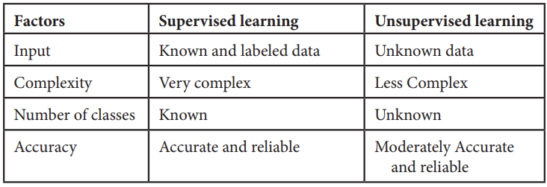
1. Supervised learning:
In supervised learning labelled dataset is used. Here the model is trained on labelled dataset. This dataset contains both input and output parameters. Supervised learning is learning where there is input data, output data and algorithm that maps to input and output.
Learning means input and output is provided to machine and machine will develop its own logic for the given task. Some supervised learning algorithms are: Linear Regression, Nearest Neighbour, Gaussian Naive Bayes, Decision Trees, Support Vector Machine (SVM), Random Forest, etc.
The learning is called supervised learning because it is similar to a teacher who is acting as supervisor on entire learning process. The predictions on trained data are generated by learning algorithms. These predictions are corrected by the teacher and learning process is stopped when correct output is achieved [5, 6].
2. Unsupervised learning:
Unsupervised learning is learning that contains only input data and no output data is present. This is applied where there is need to model data distribution in order to get more and more data and there is no any supervisor (like teacher) to supervised the things. Algorithms themselves learn, discover and present structure in data. Here algorithm itself create data pattern. Some recommendation systems for marketing automation use this type of learning.
3. Semi-supervised learning:
The supervised learning has disadvantage that it required labelled dataset. This process is very costly while dealing with large volume of data. Unsupervised learning also has disadvantage that the range of its application is limited.
To solve these problems, semi supervised learning algorithms concept was developed. This concept used both labelled data and unlabelled data so that it can work on any type of data. Mostly it contains small amount of labelled data and huge amount of unlabelled data.
1.7.2 Machine Learning Algorithms
There are various machine learning algorithms as described in Figure 1.1 below. These algorithms can be applied in any area to solve various problems.
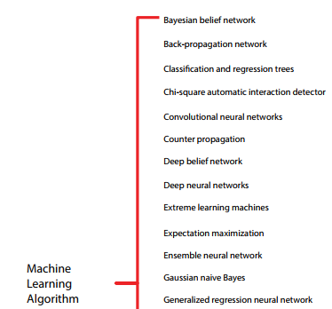
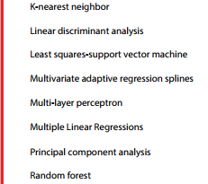
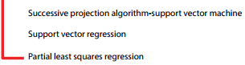
Figure.1.6 Machine learning algorithms

CHAPTER 2
LITERATURE SURVEY
Deep learning, a branch of artificial intelligence, has gained significant attention for its ability to automatically learn and extract features. It has been widely applied in various fields, including image, video, natural language processing and voice processing. In agriculture, particularly in plant protection, deep learning is increasingly used for plant disease recognition and pest assessment. Its application avoids the limitations of manual feature selection, making feature extraction more objective and improving research efficiency. This review highlights recent advancements in deep learning for crop leaf disease identification, discusses current trends, challenges, and aims to support researchers in plant disease and pest detection. [1]

This study reviews recent advancements in plant disease detection and classification using deep learning (DL) and machine learning (ML) models. By analyzing over 45 papers published between 2017 and 2020, it systematically evaluates state-of-the-art algorithms like SVM, Neural Networks, KNN, Naïve Bayes, AlexNet, and VGGNet. Each algorithm is compared based on processing techniques like image segmentation, feature extraction, and classification accuracy. The findings offer valuable insights for developing mobile-based applications that can help identify plant diseases and enhance agricultural productivity using data-driven approaches. [2]
Soil plays a crucial role in agriculture, with different types of soil possessing distinct features that affect crop growth. Understanding the characteristics of various soil types is essential for optimizing crop selection. Machine learning techniques offer valuable insights in this area and have seen significant progress in recent years. However, agricultural data analysis remains a challenging research field. In this paper, we propose a model that predicts soil series based on land type and recommends suitable crops accordingly. We utilize machine learning algorithms, including weighted Support Vector Machines (SVM), Bagged Trees, and k-Nearest Neighbor (k-NN), with a Gaussian kernel for soil classification. Experimental results demonstrate that the SVM-based method outperforms existing techniques, offering more accurate soil classification and crop recommendations. [3]
This research paper introduces a soil health intelligence system aimed at predicting soil type, pH levels, suitable crops, and nutrient content through image analysis techniques. By integrating image processing, deep learning, and machine learning, methods, the system analyzes soil images and uses RGB values to assess pH levels. The proposed model is trained with a soil image dataset using Convolutional Neural Networks (CNNs) and with pH-recognition data using regression models, with XGBoost Regressor yielding the best performance. The system demonstrates high accuracy and minimal error, showing great potential for real-world applications in agriculture. It can help farmers, agronomists, and researchers make informed decisions regarding soil management and crop productivity, contributing to sustainable agriculture practices. [4]
Agriculture is a vital part of the Indian economy, with over 50% of the population relying on it for their livelihood. However, environmental factors like weather and climate changes pose significant risks to agricultural sustainability. ML plays a key role in Crop Yield Prediction (CYP), helping farmers make decisions on what crops to grow and how to manage crops during the growing season. This research reviews various features and methods used in CYP, highlighting the limitations of techniques like Neural Networks and supervised learning, which often struggle with accuracy and nonlinear relationships. The study also explores ML models for crop yield estimation and classification, offering insights into improving agricultural productivity. [5]
This paper provides a comprehensive overview of deep learning applications in agriculture, highlighting various use cases such as crop classification, disease detection, and yield prediction. The authors discuss the potential of convolutional neural networks (CNNs) and recurrent neural networks (RNNs) in analyzing agricultural data, emphasizing the importance of large datasets for effective model training. The survey identifies challenges such as data scarcity and the need for domain-specific models, offering insights into future research directions to enhance deep learning's impact on sustainable agriculture. [6]
Zhang and Wang review the role of machine learning in precision agriculture, focusing on its application in areas like soil health monitoring, pest detection, and crop management. The paper categorizes various machine learning techniques, including supervised and unsupervised learning, and discusses their effectiveness in real-time data analysis. The authors highlight case studies demonstrating improved agricultural practices through machine learning, while also addressing limitations such as the need for robust data integration and the challenge of model interpretability. [7]
This review by Whelan and Hakeem explores the integration of machine learning technologies in smart agriculture. The authors examine diverse applications, from yield prediction to automated irrigation systems. They emphasize the role of IoT and big data in facilitating machine learning solutions and discuss the implications for resource management and sustainability. The review also identifies barriers to adoption, such as the digital divide among farmers and the requirement for user-friendly interfaces to enhance accessibility. [8]
In this comprehensive review, Mohanty et al. provide an extensive analysis of machine learning applications across various agricultural domains. The authors categorize the applications into predictive modeling, decision support systems, and automation, detailing specific techniques like regression analysis, classification algorithms, and ensemble methods. They discuss the challenges faced in data collection, model validation, and the need for interdisciplinary approaches to improve agricultural outcomes. [9]
Liu and colleagues present a thorough review of machine learning methodologies used in agriculture, covering applications in crop management, soil analysis, and pest control. The paper discusses the advantages of machine learning over traditional methods, such as increased accuracy and efficiency. The authors also highlight the significance of feature selection and model optimization for effective implementation, addressing future trends and potential areas for research in agricultural innovation. [10]

Sr.No | Author Name and Year | Proposed Method | Limitations
 | Li, Lili, Shujuan Zhang, and Bin Wang (2021) | Deep learning-based detection and classification of plant diseases | Requires large labeled datasets and high computational resources
 | Applalanaidu, Majji V., and G. Kumaravelan (2021) | Machine learning approaches for detecting and classifying plant leaf diseases | Lacks real-time monitoring and adaptation to environmental changes
 | Rahman, Sk Al Zaminur, Kaushik Chandra Mitra, and SM Mohidul Islam (2018) | Machine learning methods for soil classification and crop suggestion based on soil series | Limited generalization to different geographical regions
 | Mali, Y. et al. (2023) | Comparative analysis of machine learning models for soil health prediction and crop selection | Not applicable for real-time soil health assessment
 | D. J. Reddy and M. R. Kumar (2021) | Machine learning algorithms for crop yield prediction | Data inconsistency and lack of adaptability to sudden environmental changes

CHAPTER 3
EXISTING METHOD
- Crop Monitoring and Management: Machine learning algorithms, especially deep learning, are employed for real-time monitoring of crop health and growth conditions. These models analyze data from various sources, including satellite imagery and sensors, to predict crop performance and health.
- Yield Prediction: Predictive analytics using machine learning helps forecast crop yields based on various factors such as weather conditions, soil characteristics, and historical data. Techniques like neural networks and regression models are commonly used for these predictions, allowing farmers to make informed decisions about planting and resource allocation​(
- Precision Agriculture: This approach uses machine learning to optimize resource use, such as water and fertilizers, based on precise data about soil and crop conditions. For instance, algorithms can suggest optimal irrigation schedules or fertilizer application rates, minimizing waste and maximizing yield​(
- Pest and Disease Detection: Machine learning techniques are also applied to identify and classify pests and diseases in crops. Using image processing and computer vision, systems can detect early signs of infestation or disease, enabling timely intervention​(
- Soil Management: Machine learning models analyze soil data to recommend suitable crops, fertilizers, and management practices tailored to specific soil conditions. This helps in maintaining soil health and productivity over time​(
- Livestock Management: In addition to crop-related applications, machine learning is used to monitor livestock health and optimize feeding practices. Predictive models can assist farmers in managing their livestock more effectively, improving overall productivity​(
These methods demonstrate how machine learning can transform traditional agricultural practices into data-driven processes, leading to enhanced productivity and sustainability in farming. For a deeper exploration of these methods, you can refer to resources like the review by Kateris et al. on machine learning in agriculture​

3.1 Disadvantages of exiting method
- Data Dependency: Machine learning models require vast amounts of high-quality data for training. In agriculture, obtaining accurate and comprehensive datasets can be challenging, especially in regions where data collection methods are not well established​(
- High Initial Costs: Implementing machine learning technologies can involve significant initial investment in terms of hardware, software, and training. This can be a barrier for small-scale farmers who may not have the financial resources to adopt such advanced technologies​(
- Complexity: Machine learning algorithms can be complex and difficult to interpret. Farmers may find it challenging to understand the models' decision-making processes, which can hinder their ability to make informed decisions based on the outputs .
- Overfitting: Machine learning models are susceptible to overfitting, where they perform well on training data but poorly on unseen data. This can lead to inaccurate predictions and decisions, particularly in a dynamic field like agriculture where conditions can change rapidly
- Integration Issues: Integrating machine learning systems with existing agricultural practices and technologies can be difficult. Farmers may face challenges in adopting new systems, which could lead to inefficiencies during the transition period​(
- Dependence on Technology: Increased reliance on machine learning and automated systems may reduce traditional farming knowledge and practices. Farmers may become overly dependent on technology, which can be problematic if systems fail or are not functioning optimally .

CHAPTER 4
PROPOSED METHOD
In the proposed method, the methodology comprises three main components:
- Soil Prediction and Crop Recommendation
We start by analyzing soil images to classify soil types using a Convolutional Neural Network (CNN). This model leverages image data to provide accurate soil classification. Based on the identified soil type, we implement Random Forest and XGBoost algorithms to recommend suitable crops that can thrive in specific soil conditions. These algorithms utilize various features, such as soil composition and environmental factors, to optimize crop selection for improved yield.
b) Plant Leaf Disease Detection and Fertilizer Recommendation
A plant disease detection module is integrated, which utilizes a CNN model based on the MobileNet architecture. Farmers can upload images of plant leaves, and the model identifies common diseases, such as blight, rust, and leaf spot. Early detection enables timely intervention, reducing crop loss. For each detected disease, we recommend management strategies and appropriate fertilizers, leveraging the Random Forest and XGBoost algorithms to suggest the best options based on the disease and soil conditions.
c) Crop Yield Prediction
To predict crop yield, we utilize Long Short-Term Memory (LSTM) networks that analyze various parameters, including soil type, weather conditions, and crop history. This model is trained on historical data to understand patterns and forecast future yields accurately. By integrating these predictions with the earlier components, farmers receive comprehensive insights to make informed decisions about crop management and resource allocation.

Upload Soil image dataset
Train CNN Algorithm
Predict soil and recommend plant
Upload leaf disease dataset
Train CNN algorithm
Disease classification
LR for crop yield

Predict yield

- System architecture:

5.1 Algorithms
❖ Convolutional Neural Network (CNN):
Used for soil prediction by analyzing soil images. The CNN model classifies soil types based on image data, helping in selecting the best crops for that particular soil type.
❖ Random Forest and XGBoost:
These ensemble learning methods are used for crop recommendation and fertilizer suggestion. After soil classification, Random Forest and XGBoost analyze soil characteristics and environmental factors to recommend suitable crops. They are also used to suggest fertilizers based on plant disease data.
❖ MobileNet-based CNN:
This is used in plant disease detection. Farmers upload images of plant leaves, and this CNN model identifies common plant diseases like blight, rust, and leaf spots, enabling early intervention to reduce crop loss.
❖ Long Short-Term Memory (LSTM):
LSTM networks are employed for crop yield prediction by analyzing historical data, soil parameters, and environmental factors. The model predicts future yields, assisting farmers in planning crop cycles and maximizing productivity.
❖ K-Nearest Neighbor (KNN):
Used for analyzing new data inputs for soil or crop classification based on historical data. KNN helps in identifying nearest matches for new crop data, aiding in decision-making.
❖ Support Vector Machine (SVM):
Used for classification of crops and plant diseases. SVM creates decision boundaries between different crop types or disease states, improving the accuracy of detection and recommendation systems.
5.2 Dataset:
For the dataset used in Optimizing Agriculture Using Machine Learning, the soil image dataset consists of 1281 images, processed using feature extraction algorithms. The number of features before applying the extraction was 12,288, and after feature extraction, 1200 key features were identified. The system leverages this processed data for tasks like soil prediction, crop recommendation, plant disease detection, and crop yield prediction.

Proposed Methodology for Agricultural Optimization
- Data Collection and Preprocessing
  - Soil Image Collection: Gather soil images from various regions to ensure diverse data for training the CNN model.
  - Data Cleaning: Remove noise and irrelevant features from the dataset to improve model accuracy.
  - Labeling: Classify images according to soil types and corresponding metadata (e.g., geographic location).
- Soil Type Classification
  - Model Selection: Use a Convolutional Neural Network (CNN) for image classification.
  - Training the CNN: Train the model on the preprocessed soil images, ensuring a split between training and validation datasets to avoid overfitting.
  - Evaluation: Assess model performance using metrics such as accuracy, precision, recall, and F1 score.
- Crop Recommendation System
  - Data Integration: Combine soil type predictions with historical crop yield data and climatic conditions.
  - Machine Learning Algorithms: Implement Random Forest and XGBoost algorithms to recommend suitable crops based on the identified soil type and other environmental factors.
  - Recommendation Output: Generate a list of recommended crops for each soil type.
- Plant Disease Detection
  - Leaf Image Upload: Allow farmers to upload images of plant leaves for analysis.
  - CNN Implementation: Utilize a CNN based on the MobileNet architecture for disease detection.
  - Disease Classification: Identify common diseases such as blight, rust, and leaf spot, and provide real-time feedback.
- Disease Management Strategies
  - Strategy Generation: For each detected disease, provide farmers with management strategies, including preventive measures and treatment options.
  - Integration with Crop Recommendation: Link disease management strategies with recommended crops to ensure holistic management.
- Fertilizer Recommendation
  - Algorithm Application: Use Random Forest and XGBoost algorithms to suggest appropriate fertilizers based on detected diseases and soil parameters.
  - User Guidance: Provide tailored fertilizer application rates based on specific crop and soil conditions.
- Crop Yield Prediction
  - Data Collection: Gather relevant parameters such as soil type, crop variety, and environmental conditions.
  - LSTM Model Development: Train a Long Short-Term Memory (LSTM) model to predict crop yield based on historical data and current inputs.
  - Yield Forecasting: Generate yield predictions that help farmers plan and make informed decisions regarding crop management.
- System Integration and User Interface
  - Develop a User-Friendly Interface: Create a mobile or web application that allows farmers to interact with the system easily.
  - Real-Time Feedback: Enable features for real-time feedback and alerts based on the farmers' inputs and ongoing conditions.
- Testing and Validation
  - Field Testing: Validate the model outputs through field tests and gather feedback from farmers.
  - Performance Metrics: Evaluate the system’s effectiveness in improving productivity and resource optimization.
- Deployment and Continuous Improvement
  - System Deployment: Launch the application for broader farmer access.
  - Feedback Loop: Establish a mechanism for continuous data collection and model improvement based on user feedback and changing agricultural conditions.

CHAPTER 5
RESULT
Results Analysis

In proposed method we used
- Soil prediction and crop recommendation
- Plant leaf disease detection and fertilizer recommendation
- Crop yield prediction

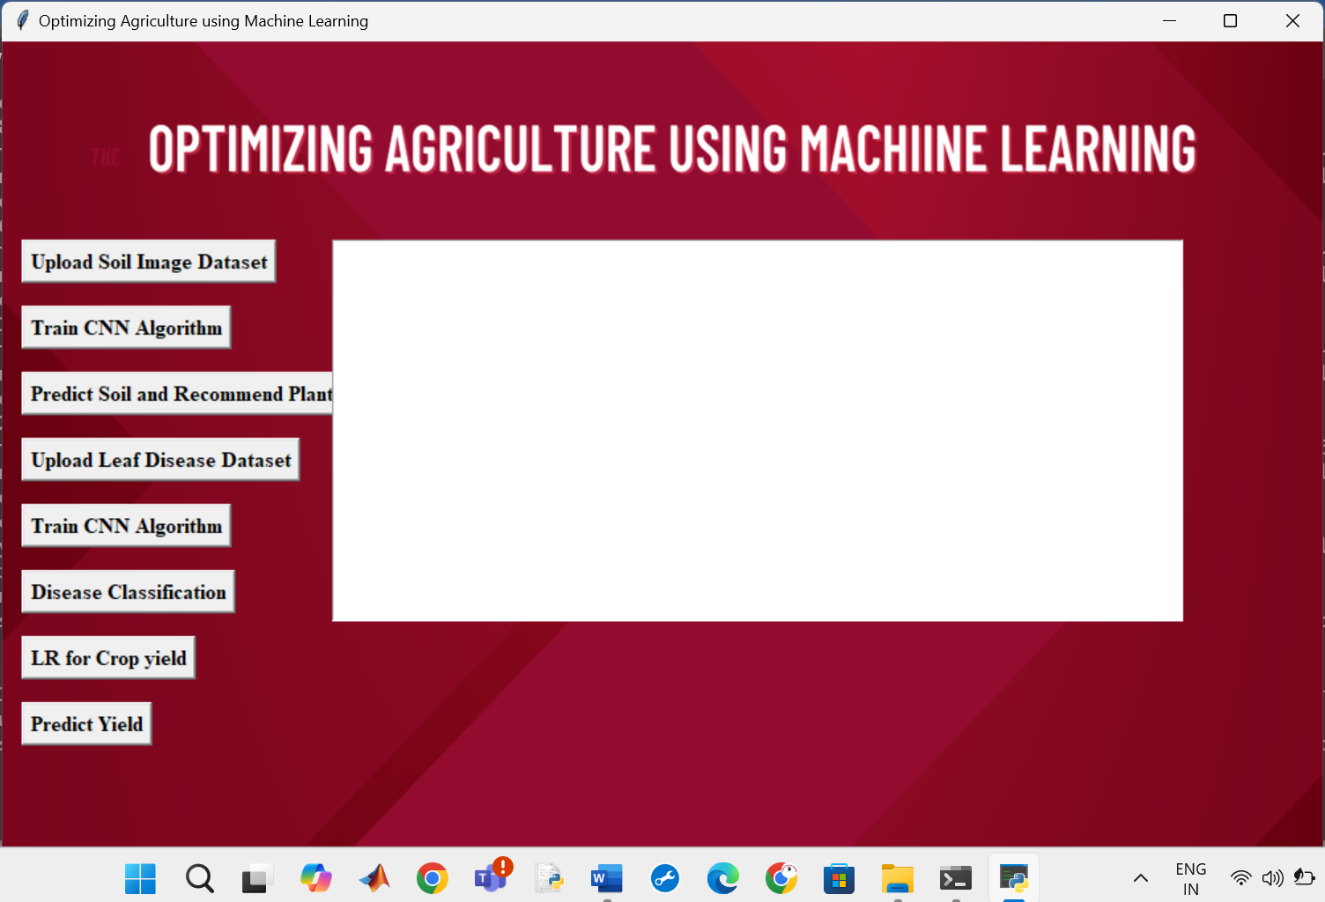

Fig. GUI for proposed Method

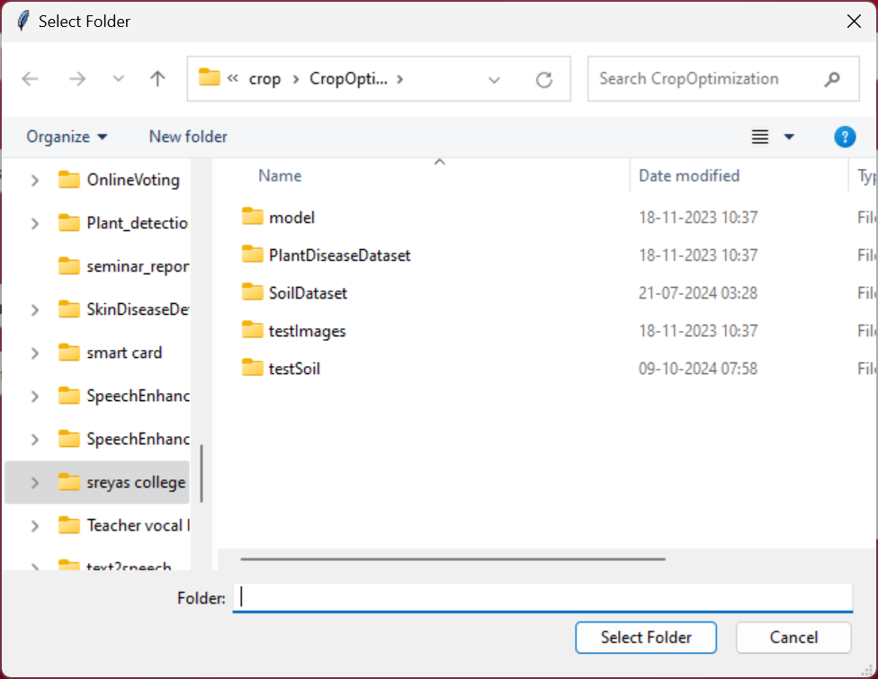
Fig. Upload the dataset related to soil
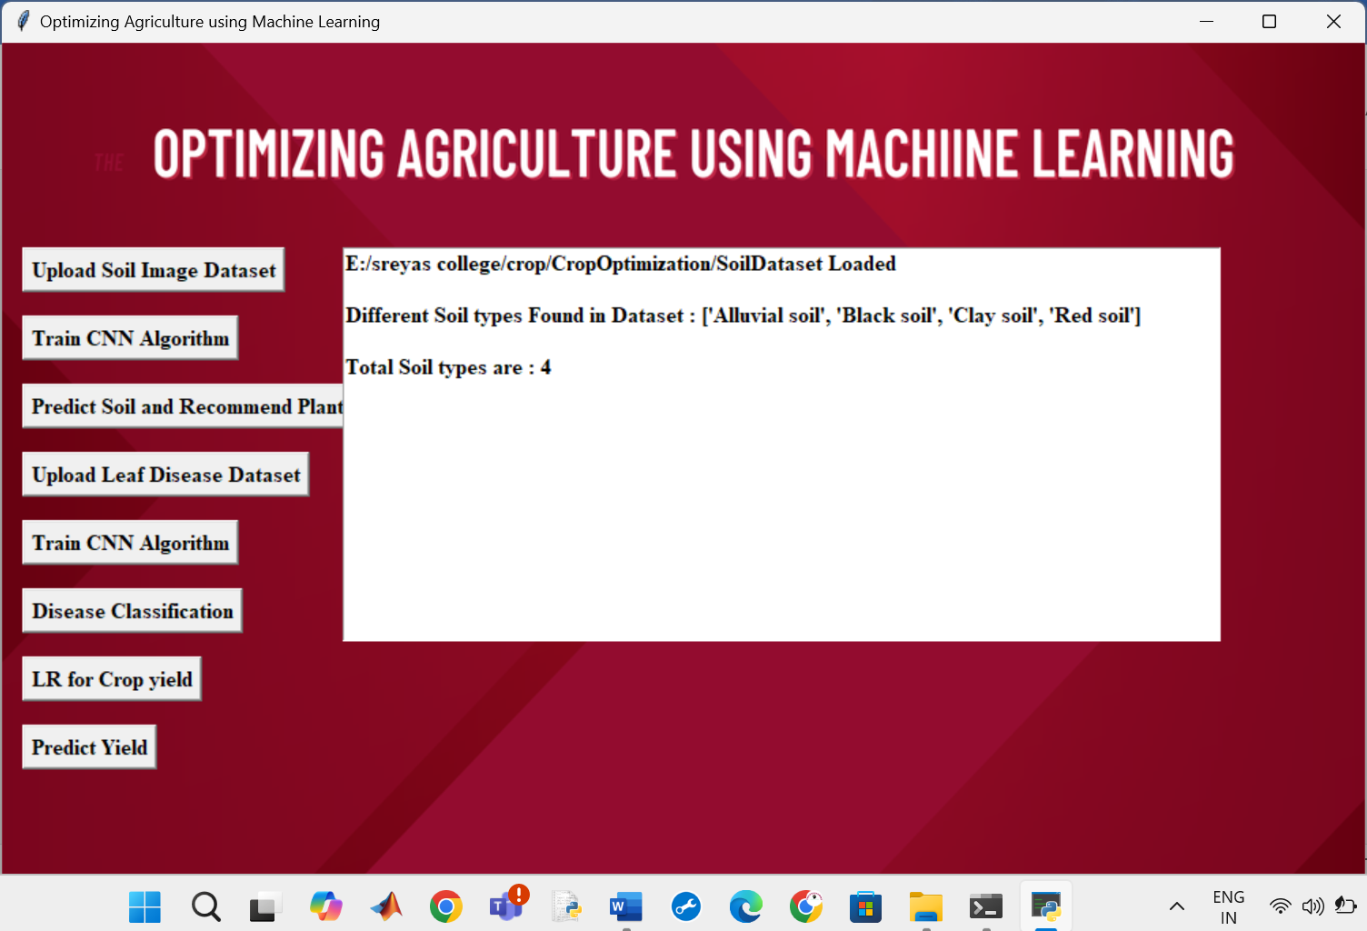
Fig. After uploading the soil dataset , details are shown
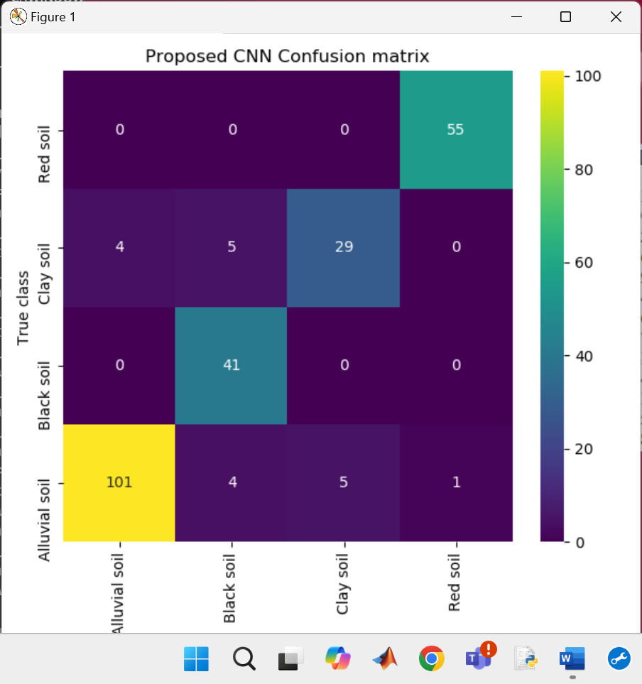
Fig. Confusion matrix for soil classification and plant recommendation

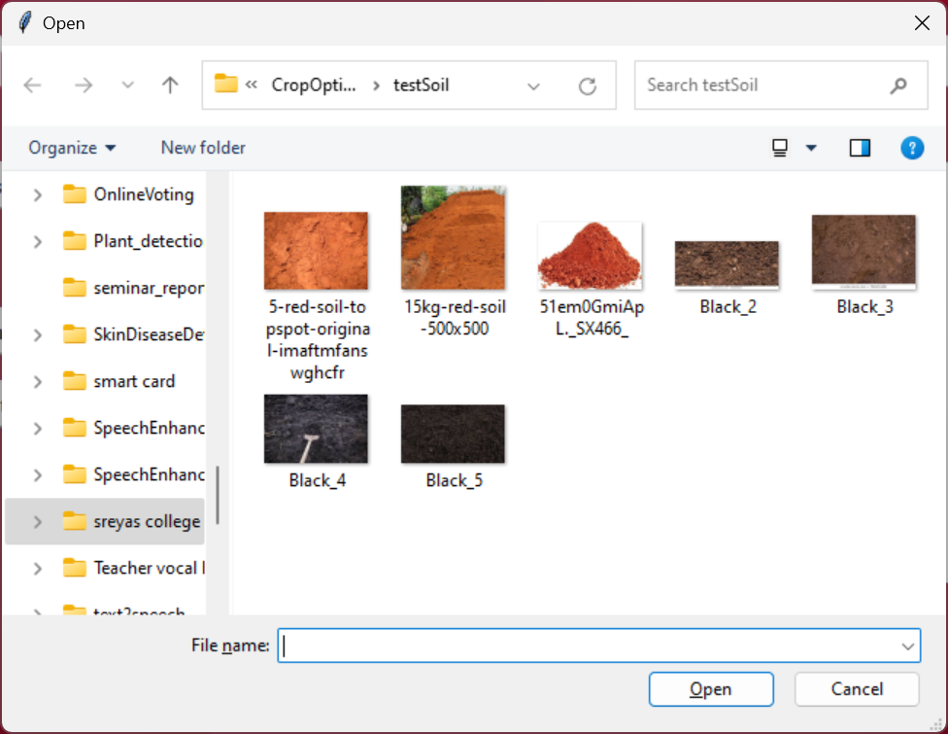
Fig. select soil image for testing

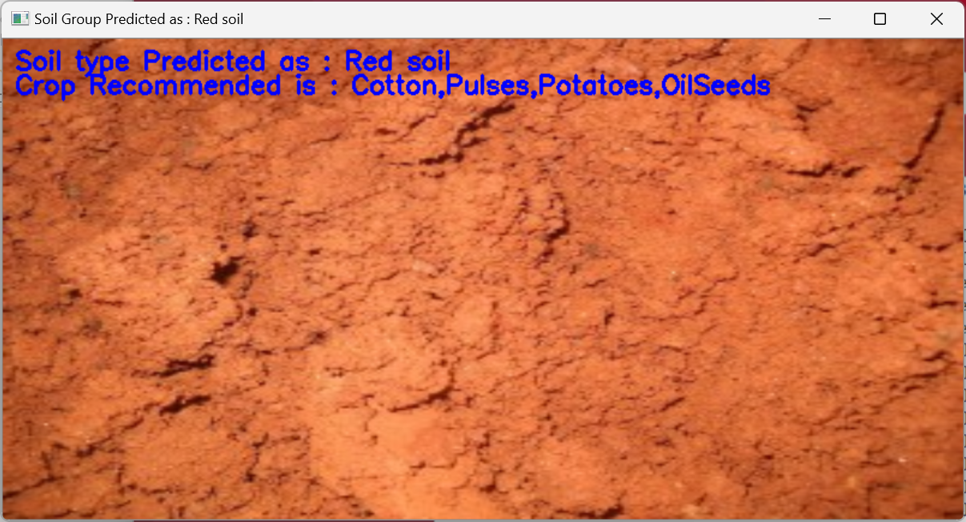
Fig. soil predicted and crop recommended


Fig. Uploading leaf disease dataset

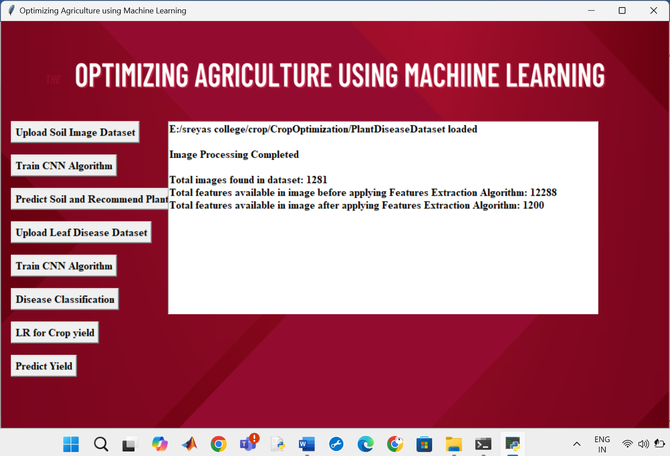
Fig. after uploading details are shown

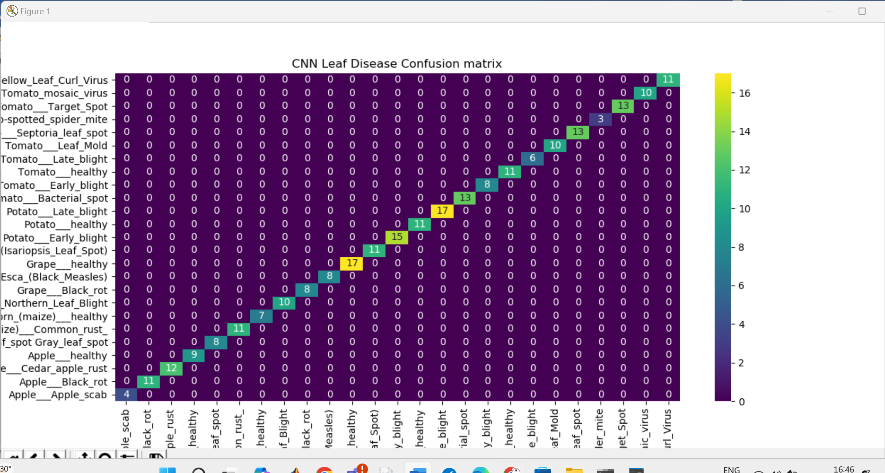
Fig. Confusion Matrix for plant disease detection and fertilizer recommendation

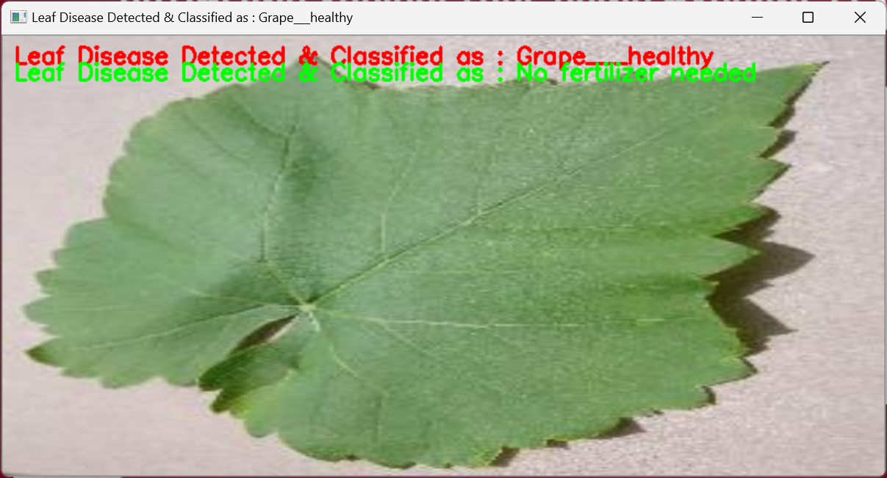
Normal leaf without disease

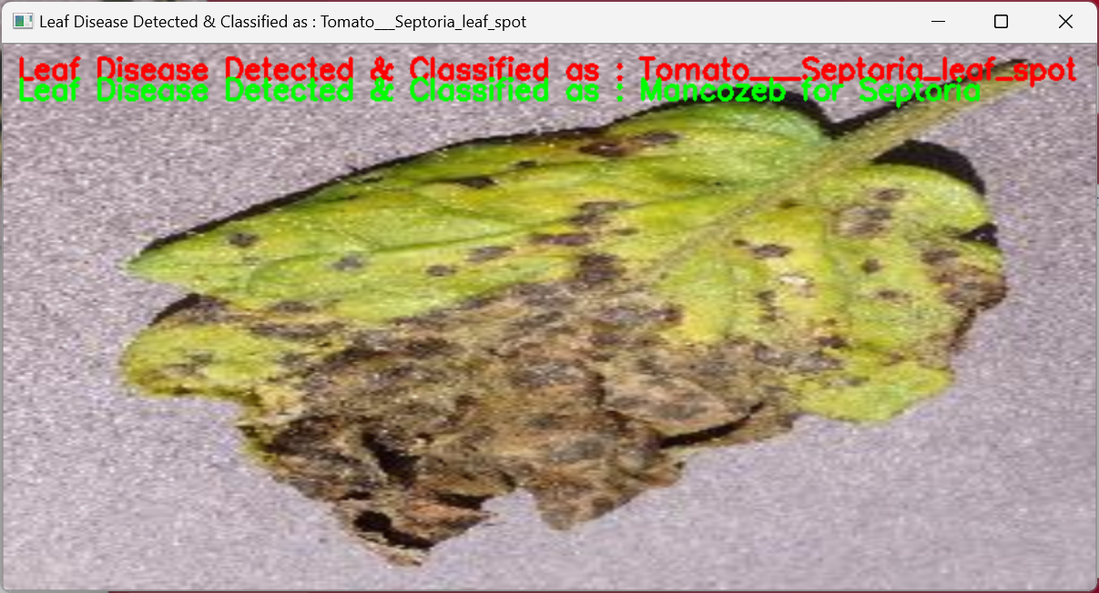
Fig. disease is predicted and fertilizer is recommended

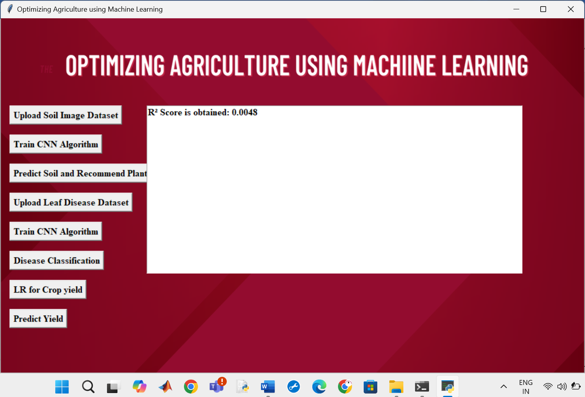
Fig. Linear regression R2 score is shown

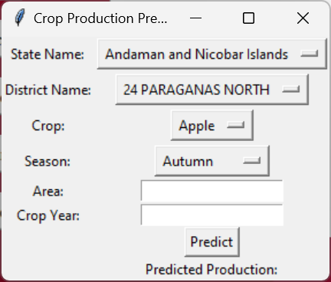
Fig. crop yield prediction interface

CHAPTER 6
CONCLUSION
In conclusion, the paper demonstrates the transformative potential of AI-driven solutions in the agricultural sector. By leveraging machine learning models such as CNN for soil classification, Random Forest and XGBoost for crop recommendation and fertilizer suggestions, MobileNet-based CNN for plant disease detection, and LSTM for crop yield prediction, the system provides a comprehensive tool to assist farmers. This integrated approach supports sustainable farming practices, optimizes resource use, and enhances decision-making to improve crop productivity and reduce losses. Overall, this project highlights how machine learning can address key challenges in agriculture, contributing to increased productivity and global food security.

REFERENCES
- Li, Lili, Shujuan Zhang, and Bin Wang. "Plant disease detection and classification by deep learning—a review." IEEE Access 9 (2021): 56683-56698.
- Applalanaidu, Majji V., and G. Kumaravelan. "A review of machine learning approaches in plant leaf disease detection and classification." In 2021 Third International Conference on Intelligent Communication Technologies and Virtual Mobile Networks (ICICV), pp. 716-724. IEEE, 2021.
- Rahman, Sk Al Zaminur, Kaushik Chandra Mitra, and SM Mohidul Islam. "Soil classification using machine learning methods and crop suggestion based on soil series." In 2018 21st International Conference of Computer and Information Technology (ICCIT), pp. 1-4. IEEE, 2018.
- Mali, Y. ., Rathod, V. U. ., Kulkarni, M. M. S. ., Mokal, P. ., Patil, S. ., Dhamdhere, V. ., & Birari, D. R. . (2023). A Comparative Analysis of Machine Learning Models for Soil Health Prediction and Crop Selection. International Journal of Intelligent Systems and Applications in Engineering, 11(10s), 811–828. Retrieved from https://ijisae.org/index.php/IJISAE/article/view/3335
- D. J. Reddy and M. R. Kumar, "Crop Yield Prediction using Machine Learning Algorithm," 2021 5th International Conference on Intelligent Computing and Control Systems (ICICCS), Madurai, India, 2021, pp. 1466-1470, doi: 10.1109/ICICCS51141.2021.9432236.
- • Kamilaris, A., & Prenafeta-Boldú, F. X. (2018). "Deep Learning in Agriculture: A Survey." Computers and Electronics in Agriculture, 147, 70-90. DOI: 10.1016/j.compag.2018.02.016.
- • Zhang, C., & Wang, J. (2020). "Application of Machine Learning in Precision Agriculture: A Review." Agricultural Systems, 179, 102785. DOI: 10.1016/j.agsy.2019.102785.
- • Whelan, B., & Hakeem, A. (2019). "Machine Learning for Smart Agriculture: A Review." Applied Sciences, 9(19), 3937. DOI: 10.3390/app9193937.
- • Mohanty, S. P., Patil, A. S., & Barik, S. K. (2021). "A Comprehensive Review on Applications of Machine Learning in Agriculture." Artificial Intelligence in Agriculture, 4, 215-227. DOI: 10.1016/j.aiia.2021.08.001.
- • Liu, Y., Zhang, L., & Liu, Z. (2020). "Machine Learning in Agriculture: A Comprehensive Review." Information Processing in Agriculture, 7(1), 1-19. DOI: 10.1016/j.inpa.2019.09.002.
- • Xiong, Y., & Li, B. (2022). "Artificial Intelligence for Agriculture: A Review of Machine Learning Applications." Computers and Electronics in Agriculture, 194, 106757. DOI: 10.1016/j.compag.2022.106757.
- • Salehahmadi, Z., & Gharaviri, A. (2021). "Machine Learning for Smart Farming: A Review." Agricultural Sciences, 12(2), 218-233. DOI: 10.4236/as.2021.122017.
- • Mulla, D. J. (2013). "Twenty Five Years of Remote Sensing in Precision Agriculture: Key Advances and Remaining Challenges." Remote Sensing, 5(2), 618-646. DOI: 10.3390/rs5020618.
- • Schwalbenberg, A., & Crookston, R. (2020). "Machine Learning and Big Data in Agriculture: A Review." International Journal of Agriculture and Biology, 24(6), 1155-1160. DOI: 10.17957/IJAB/15.1201.
- • Zhang, Y., Wang, X., & Wang, Y. (2019). "Artificial Intelligence and Machine Learning in Precision Agriculture: A Review." Journal of Integrative Agriculture, 18(7), 1436-1450. DOI: 10.1016/S2095-3119(18)61941-1.

APPENDIX
PYTHON
1.1 Introduction
* One of the most popular languages is Python. Guido van Rossum released this language in 1991. Python is available on the Mac, Windows, and Raspberry Pi operating systems. The syntax of Python is simple and identical to that of English. When compared to Python, it was seen that the other language requires a few extra lines.
*It is an interpreter-based language because code may be run line by line after it has been written. This implies that rapid prototyping is possible across all platforms. Python is a big language with a free, binary-distributed interpreter standard library.
* It is inferior to maintenance that is conducted and is straightforward to learn. It is an object-oriented, interpreted programming language. It supports several different programming paradigms in addition to object-oriented programming, including functional and procedural programming.
* It supports several different programming paradigms in addition to object-oriented programming, including practical and procedural programming. Python is mighty while maintaining a relatively straightforward syntax. Classes, highly dynamic data types, modules, and exceptions are covered. Python can also be utilised by programmes that require programmable interfaces as an external language.
Graphical User Interface (GUI)
A Graphical User Interface (GUI) allows users to interact with software applications using graphical elements such as buttons, labels, and text fields, rather than typing commands in a console or command-line interface. This visual interaction makes it easier for users, regardless of their technical expertise, to use software applications effectively. GUIs play a vital role in the user experience and are widely employed in various types of applications, from desktop to web and mobile.
Tkinter, the standard Python interface to the Tk GUI toolkit, is one of the most popular libraries for building desktop applications. It provides tools to develop interactive, user-friendly, and visually appealing interfaces. Tkinter simplifies GUI development and is widely used for creating both small and complex applications in Python.

Why Choose Tkinter?
There are several reasons why Tkinter is preferred for GUI development, especially among Python developers:
- Part of Standard Library: Tkinter is part of Python’s standard library, meaning it does not require any additional installation, making it immediately available for use.
- Cross-Platform Compatibility: Applications built using Tkinter can run on Windows, macOS, and Linux without modification, ensuring broad accessibility.
- Ease of Use: The simplicity and readability of the Tkinter API make it ideal for beginners. Its minimal syntax allows developers to build GUIs quickly.
- Comprehensive Widget Collection: Tkinter offers a variety of widgets (buttons, labels, frames, menus, etc.) that can be used to create rich interfaces.
- Community Support: Being a part of the Python ecosystem, Tkinter benefits from robust community support, with numerous tutorials, documentation, and forums available.

Key Components of Tkinter
The essential elements of GUI development in Tkinter include the main window (or root window) and the widgets that users interact with. Widgets are the building blocks of the interface and include buttons, labels, entry fields, and more.

Main Window
The root window is the primary container for the GUI and serves as the main frame in which all other widgets are placed. When a Tkinter application runs, this window acts as the interface shell, holding all other elements.

Widgets in Tkinter
Tkinter offers a wide array of widgets that enhance the user interface. These widgets serve different purposes and are the interactive elements that users will engage with:
- Label: Used to display text or images.
- Button: A clickable element that triggers events or actions.
- Entry: A text field where users can input data.
- Frame: A container used to organize other widgets in a structured layout.
- Checkbutton: Allows users to make binary (yes/no) selections.
- Radiobutton: Provides mutually exclusive choices, allowing the user to select one option from a group.
- Scrollbar: Used to scroll through large amounts of data in a window.
- Menu: A set of commands or options presented as a drop-down menu.
These widgets are versatile and can be customized with attributes like color, font, size, and style, enabling developers to create attractive and user-friendly applications.

Layout Management in Tkinter
Tkinter provides several ways to manage the layout of widgets in a window. The layout determines how widgets are placed and how they respond to changes in the window size.
- Pack: The simplest layout manager, which arranges widgets in blocks before placing them in the parent widget. Widgets are positioned relative to each other, either horizontally or vertically.
- Grid: This manager organizes widgets in a table-like structure, where widgets are placed into rows and columns. It offers more control over placement compared to the pack manager.
- Place: Allows for manual placement of widgets by specifying exact coordinates. This provides the highest degree of control but requires careful planning to ensure that the layout looks good across different screen sizes and resolutions.

Events and Callbacks
A key feature of GUI applications is the ability to respond to user interactions. Tkinter uses an event-driven model, meaning it waits for events (such as button clicks, key presses, or mouse movements) and then triggers specific actions (called callbacks) in response to these events.
For instance, when a user clicks a button, an event is generated. This event is caught by the GUI, and the corresponding function (the callback) is executed. Developers can bind specific functions to widget events, making the interface interactive and responsive.

Customization and Styling
Tkinter allows a significant degree of customization for widgets, enabling developers to create visually distinct interfaces. Properties like background color, text font, border thickness, and widget size can all be adjusted to fit the design requirements. This flexibility allows for personalized styling that aligns with the overall theme of the application.
Tkinter also supports styling through the ttk module, which provides themed widgets for more modern-looking interfaces. Ttk widgets are variations of the standard Tkinter widgets, offering additional styling options and an improved appearance.

Advantages of Using Tkinter
There are several benefits to using Tkinter for GUI development:
- Simplicity: Its straightforward syntax makes it easy for developers to learn and use, even for beginners.
- Integrated into Python: Tkinter is bundled with Python, which simplifies installation and makes it readily available.
- Fast Prototyping: Tkinter’s ease of use allows developers to quickly create prototypes of their applications and test their functionality before moving to more complex development environments.
- Versatility: From small utilities to full-fledged desktop applications, Tkinter provides the tools necessary to build a variety of software.
- Platform Independence: Tkinter applications can run on multiple operating systems without modification, making it an excellent choice for cross-platform development.

Applications of Tkinter
Tkinter is used in various domains to create desktop applications with a graphical interface. Some common applications include:
- Data Entry Systems: Applications where users input data through forms and input fields.
- File Management Tools: Programs for organizing, browsing, and managing files.
- Game Interfaces: Simple 2D games and utilities for interacting with game environments.
- Educational Software: Interactive tools for learning that engage users through a visual interface.
- Automation Tools: Scripts or applications that automate repetitive tasks and provide a user-friendly way to configure and execute them.
Tkinter remains a robust and versatile library for building GUIs in Python. Its integration into the Python standard library, combined with its simplicity, makes it ideal for both beginners and experienced developers. Whether developing small utility programs or more complex desktop applications, Tkinter offers a wide range of tools for creating effective and interactive user interfaces.
By leveraging widgets, layout managers, event handling, and styling options, developers can create visually appealing and functional applications. Tkinter's role in desktop application development highlights the importance of GUIs in making software more accessible and user-friendly, bridging the gap between functionality and usability.

Here are some key features and characteristics of Python:
- Readability: Python emphasizes code readability with its clean and intuitive syntax. It uses indentation and whitespace to structure code blocks, making it easy to understand and maintain.
- Easy to Learn: Python's simplicity and readability make it an excellent choice for beginners. Its straightforward syntax and extensive documentation make it accessible for newcomers to programming.
- Interpreted Language: Python is an interpreted language, meaning that it doesn't need to be compiled before running. The Python interpreter reads and executes the code directly, making the development process faster and more interactive.
- Cross-platform Compatibility: Python is available for major operating systems like Windows, macOS, and Linux. This cross-platform compatibility allows developers to write code once and run it on different platforms without modifications.
- Large Standard Library: Python comes with a vast standard library that provides ready-to-use modules and functions for various tasks. It covers areas such as file I/O, networking, regular expressions, databases, and more, saving developers time and effort.
- Extensible and Modular: Python supports modular programming, enabling developers to organize code into reusable modules and packages. Additionally, Python allows integrating modules written in other languages, such as C or C++, providing flexibility and performance optimizations.
- Wide Range of Libraries and Frameworks: Python has a vibrant ecosystem with numerous third-party libraries and frameworks. These libraries, such as NumPy, pandas, TensorFlow, and Django, extend Python's capabilities for specific domains, making it a powerful tool for diverse applications.
- Object-Oriented: Python supports object-oriented programming (OOP) principles, allowing developers to create and work with classes and objects. OOP provides a structured approach to code organization, promoting code reuse and modularity.
- Dynamic Typing: Python is dynamically typed, meaning variable types are determined at runtime. Developers do not need to declare variable types explicitly, which enhances flexibility and simplifies code writing.
1.2 Installation
To install Python on your computer, follow these basic steps:
- Step 1: Visit the Python website Go to the official Python website at https://www.python.org/.
- Step 2: Select the operating system Choose the appropriate installer for your operating system. Python supports Windows, macOS, and various Linux distributions. Make sure to select the correct version that matches your operating system.
- Step 3: Check which version of Python is installed; if the 3.7.0 version is not there, uninstall it through the control panel and
- Step 4: Install Python 3.7.0 using Cmd.
- Step 5: Install the all libraries that required to run the project
- Step 6: Run
1.3 Python Features:
- Easy: Because Python is a more accessible and straightforward language, Python programming is easier to learn.
- Interpreted language: Python is an interpreted language, therefore it can be used to examine the code line by line and provide results.
- Open Source: Python is a free online programming language since it is open-source.
- Portable: Python is portable because the same code may be used on several computer standard
- libraries: Python offers a sizable library that we may utilize to create applications quickly.
- GUI: It stands for GUI (Graphical User Interface)
- Dynamical typed: Python is a dynamically typed language, therefore the type of the value will be determined at runtime.
1.4 Python GUI (Tkinter)
- Python provides a wide range of options for GUI development (Graphical User Interfaces).
- Tkinter, the most widely used GUI technique, is used for all of them.
- The Tk GUI toolkit offered by Python is used with the conventional Python interface.
- Tkinter is the easiest and quickest way to write Python GUI programs.
- Using Tkinter, creating a GUI is simple.
- A part of Python's built-in library is Tkinter. The GUI programs were created.
- Python and Tkinter together give a straightforward and quick way. The Tk GUI toolkit's object-oriented user interface is called Tkinter.

Making a GUI application is easy using Tkinter. Following are the steps:
1) Install the Tkinter module in place.
2) The GUI applicatioMakeske the primary window
3) Include one or more of the widgets mentioned above in the GUI application.
4) Set up the main event loop such that it reacts to each user-initiated event.
Although Tkinter is the only GUI framework included in the Python standard library, Python includes a GUI framework. The default library for Python is called Tkinter. Tk is a scripting language often used in designing, testing, and developing GUIs. Tk is a free, open-source widget toolkit that may be used to build GUI applications in a wide range of computer languages.

1.5 Python IDLE
- Python IDLE offers a full-fledged file editor, which gives you the ability to write and execute Python programs from within this program. The built-in file editor also includes several features, like code completion and automatic indentation, that will speed up your coding workflow.
- Guido Van Rossum named Python after the British comedy group Monty Python while the name IDLE was chosen to pay tribute to Eric Idle, who was one of the Monty Python's founding members. IDLE comes bundled with the default implementation of the Python language since the 01.5. 2b1 release
- IDLE is used to execute statements similar to Python Shell. IDLE is used to create, modify, and execute Python code. IDLE provides a fully-featured text editor to write Python scripts and provides features like syntax highlighting, auto-completion, and smart indent.
- IDLE has two modes: interactive and script. We wrote our first program, “Hello, World!” in interactive mode. Interactive mode immediately returns the results of commands you enter into the shell. In script mode, you will write a script and then run it.
- The IDE Python IDLE is a good place to start as it helps you become familiar with the way Python works and understand its syntax. This IDE is good to start programming in Python due to its great debugger, but once you are fluent and start developing projects it is necessary to jump to another, more complete IDE.
- Python IDLE (Integrated Development and Learning Environment) is an interactive development environment included with the Python programming language. It provides a convenient way to write, execute, and debug Python code.
When you install Python, IDLE is typically installed along with it. To open IDLE, you can follow these steps:
- Open the command prompt (Windows) or terminal (macOS/Linux).
- Type "idle" and press Enter. Alternatively, you can specify the version with "idle3" or "idle2" for Python 3 or Python 2, respectively.
- Once IDLE is launched, you will see the Python shell, which is an interactive environment where you can type and execute Python code directly.
Here are some features and functionalities provided by Python IDLE:
- Editor: IDLE includes a text editor where you can write your Python code. It offers syntax highlighting, automatic indentation, and code completion to enhance your coding experience.
- Interactive Shell: The Python shell in IDLE allows you to execute Python code interactively. You can type commands, statements, or function calls directly in the shell, and Python will execute them immediately.
- Debugging: IDLE provides basic debugging capabilities to help you find and fix errors in your code. You can set breakpoints, step through code, inspect variables, and track the program's execution.
- Python Help: IDLE provides access to the Python documentation and built-in help. You can access the help menu to find information about Python modules, functions, classes, and more.
- Script Execution: In addition to the interactive shell, IDLE allows you to run Python scripts stored in files. You can write your code in the editor and execute it as a script to see the output or interact with the program.
- Customization: IDLE can be customized to suit your preferences. You can modify settings related to syntax highlighting, indentation, fonts, and more.
- Python IDLE serves as a beginner-friendly development environment and learning tool. It is suitable for writing small scripts, testing code snippets, experimenting with Python features, and learning the language's basics. However, for more advanced development projects, you may consider using other code editors or integrated development environments (IDEs) that provide additional features and better project management capabilities.
1.6 Libraries
In Python, libraries (also referred to as modules or packages) are collections of pre-written code that provide additional functionality and tools to extend the capabilities of the Python language. Libraries contain reusable code that developers can leverage to perform specific tasks without having to write everything from scratch.
Python libraries are designed to solve common problems, such as handling data, performing mathematical operations, interacting with databases, working with files, implementing networking protocols, creating graphical user interfaces (GUIs), and much more. They provide ready-to-use functions, classes, and methods that simplify complex operations and save development time.
Libraries in Python offer various advantages:
- Code Reusability:
- Efficiency:
- Collaboration
- Domain-Specific Functionality
- To use a Python library, you need to install it first.
There are some libraries following:
- Pandas:
Pandas are a Python computer language library for data analysis and manipulation. It offers a specific operation and data format for handling time series and numerical tables. It differs significantly from the release3-clause of the BSD license. It is a well-liked open-source of opinion that is utilized in machine learning and data analysis.
Pandas are a Python package providing fast, flexible, and expressive data structures designed to make working with “relational” or “labeled” data both easy and intuitive. It aims to be the fundamental high-level building block for doing practical, real-world data analysis in Python. Pandas are a Python library used for working with data sets.
- It has functions for analysing, cleaning, exploring, and manipulating data.
- The name "Pandas" has a reference to both "Panel Data", and "Python Data Analysis" and was created by Wes McKinney in 2008.
- Pandas allow us to analyse big data and make conclusions based on statistical theories.
- Pandas can clean messy data sets, and make them readable and relevant.
Relevant data is very important in data science. Pandas are a Python library for data analysis. Started by Wes McKinney in 2008 out of a need for a powerful and flexible quantitative analysis tool, pandas have grown into one of the most popular Python libraries. It has an extremely active community of contributors. The name is derived from the term "panel data", an econometrics term for data sets that include observations over multiple time periods for the same individuals. Its name is a play on the phrase "Python data analysis" itself.
- NumPy:
The NumPy Python library for multi-dimensional, big-scale matrices adds a huge number of high-level mathematical functions. It is possible to modify NumPy by utilizing a Python library. Along with line, algebra, and the Fourier transform operations, it also contains several matrices-related functions.
NumPy can be used to perform a wide variety of mathematical operations on arrays. It adds powerful data structures to Python that guarantee efficient calculations with arrays and matrices and it supplies an enormous library of high-level mathematical functions that operate on these arrays and matrices.
- NumPy is a Python library used for working with arrays.
- It also has functions for working in domain of linear algebra, Fourier transform, and matrices.
- NumPy was created in 2005 by Travis Oliphant. It is an open source project and you can use it freely.
- NumPy stands for Numerical Python.
- In Python we have lists that serve the purpose of arrays, but they are slow to process.
- NumPy aims to provide an array object that is up to 50x faster than traditional Python lists.
- The array object in NumPy is called ndarray, it provides a lot of supporting functions that make working with ndarray very easy.
- Arrays are very frequently used in data science, where speed and resources are very important.

- Matplotlib:
It is a multi-platform, array-based data visualization framework built to interact with the whole SciPy stack. MATLAB is proposed as an open-source alternative. Matplotlib is a Python extension and a cross-platform toolkit for graphical plotting and visualization.
Matplotlib is a popular Python library for creating static, animated, and interactive visualizations. It provides a flexible and comprehensive set of tools for generating plots, charts, histograms, scatter plots, and more. Matplotlib is widely used in various fields, including data analysis, scientific research, and data visualization.
Here are some key features and functionalities of the Matplotlib library:
- Plotting Functions
- Customization Options
- Multiple Interfaces
- Integration with NumPy and pandas
- Subplots and Figures:
- Saving and Exporting

- Scikit-learn:
The most stable and practical machine learning library for Python is scikit-learn. Regression, dimensionality reduction, classification, and clustering are just a few of the helpful tools it provides through the Python interface for statistical modeling and machine learning. It is an essential part of the Python machine learning toolbox used by JP Morgan. It is frequently used in various machine learning applications, including classification and predictive analysis.
Scikit-learn (also referred to as sklearn) is a widely used open-source machine learning library for Python. It provides a comprehensive set of tools and algorithms for various machine learning tasks, including classification, regression, clustering, dimensionality reduction, model selection, and pre-processing.
Here are some key features and functionalities of the Scikit-learn library:
- Easy-to-Use Interface:
- Broad Range of Algorithms:
- Data Pre-processing and Feature Engineering:
- Model Evaluation and Validation:
- Integration with NumPy and pandas:
- Robust Documentation and Community Support:

- Keras:
* Google's Keras is a cutting-edge deep learning API for creating neural networks. It is created in Python and is designed to simplify the development of neural networks. Additionally, it enables the use of various neural networks for computation. Deep learning models are developed and tested using the free and open-source Python software known as Keras.
Keras is a high-level deep learning library for Python. It is designed to provide a user-friendly and intuitive interface for building and training deep learning models. Keras acts as a front-end API, allowing developers to define and configure neural networks while leveraging the computational backend engines, such as Tensor Flow or Theano.
Here are some key features and functionalities of the Keras library:
- User-Friendly API
- Multi-backend Support
- Wide Range of Neural Network Architectures
- Pre-trained Models and Transfer Learning:
- Easy Model Training and Evaluation:
- GPU Support:

- h5py:
* The h5py Python module offers an interface for the binary HDF5 data format. Thanks to p5py, the top can quickly halt the vast amount of numerical data and alter it using the NumPy library. It employs common syntax for Python, NumPy, and dictionary arrays.
h5py is a Python library that provides a simple and efficient interface for working with datasets and files in the Hierarchical Data Format 5 (HDF5) format. HDF5 is a versatile data format commonly used for storing and managing large volumes of numerical data.
Here are some key features and functionalities of the h5py library:
  - HDF5 File Access
  - Dataset Handling:
  - Group Organization:
  - Attributes:
  - Compatibility with NumPy
  - Performance

- Tensor flow
TensorFlow is a Python library for fast numerical computing created and released by Google. It is a foundation library that can be used to create Deep Learning models directly or by using wrapper libraries that simplify the process built on top of TensorFlow. TensorFlow is an end-to-end open source platform for machine learning. TensorFlow is a rich system for managing all aspects of a machine learning system; however, this class focuses on using a particular TensorFlow API to develop and train machine learning models.
TensorFlow is a popular open-source library for machine learning and deep learning. It provides a comprehensive set of tools, APIs, and computational resources for building and training various types of machine learning models, especially neural networks.
Here are some key features and functionalities of TensorFlow:
- Neural Network Framework:
- Computational Graphs
- Automatic Differentiation
- GPU and TPU Support
- Distributed Computing
- Deployment Capabilities

- Tkinter
Tkinter is an acronym for "Tk interface". Tk was developed as a GUI extension for the Tcl scripting language by John Ousterhout. The first release was in 1991. Tkinter is the de facto way in Python to create Graphical User interfaces (GUIs) and is included in all standard Python Distributions. In fact, it's the only framework built into the Python standard library.
Tkinter is a standard Python library used for creating graphical user interfaces (GUIs). It provides a set of modules and classes that allow you to develop interactive and visually appealing desktop applications.
Here are some key features and functionalities of Tkinter:
- Cross-Platform Compatibility
- Simple and Easy-to-Use
- Widgets and Layout Management
- Event-Driven Programming
- Customization and Styling
- Integration with Other Libraries

- NLTK
NLTK is a toolkit build for working with NLP in Python. It provides us various text processing libraries with a lot of test datasets. A variety of tasks can be performed using NLTK such as tokenizing, parse tree visualization, etc NLTK (Natural Language Toolkit) is the go-to API for NLP (Natural Language Processing) with Python. It is a really powerful tool to pre-process text data for further analysis like with ML models for instance. It helps convert text into numbers, which the model can then easily work with.
NLTK (Natural Language Toolkit) is a Python library widely used for working with human language data and implementing natural language processing (NLP) tasks. It provides a set of tools, corpora, and resources for tasks such as tokenization, stemming, tagging, parsing, sentiment analysis, and more.
Here are some key features and functionalities of NLTK:
- Text Processing
- Part-of-Speech Tagging
- Named Entity Recognition
- Chunking and Parsing
- Sentiment Analysis:
- WordNet Integration:
Scipy
SciPy is a collection of mathematical algorithms and convenience functions built on the NumPy extension of Python. It adds significant power to the interactive Python session by providing the user with high-level commands and classes for manipulating and visualizing data.
SciPy is a powerful scientific computing library for Python that provides a wide range of mathematical algorithms and functions. It builds upon NumPy, another fundamental library for numerical computing, and extends its capabilities by adding additional tools for scientific and technical computing tasks.
Here are some key features and functionalities of SciPy:
- Numerical Integration:
- Optimization and Root Finding
- Linear Algebra
- Signal and Image Processing
- Statistics

